20.LIBRARY MANAGEMENT SYSTEM

COMPONENT DIAGRAM

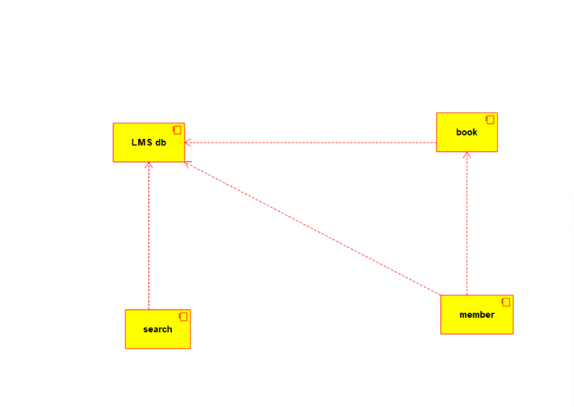

CLASS DIAGRAM

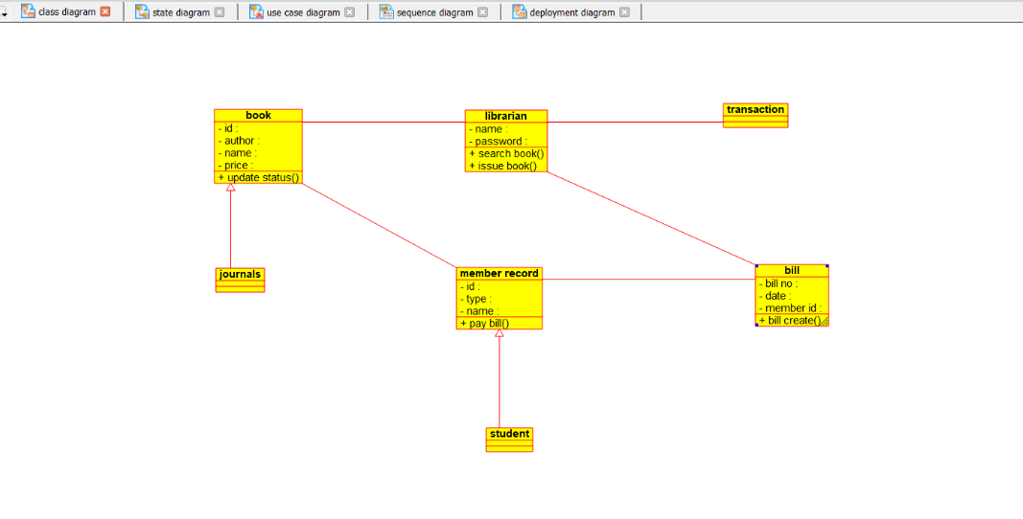

COLLABORATION DIAGRAM

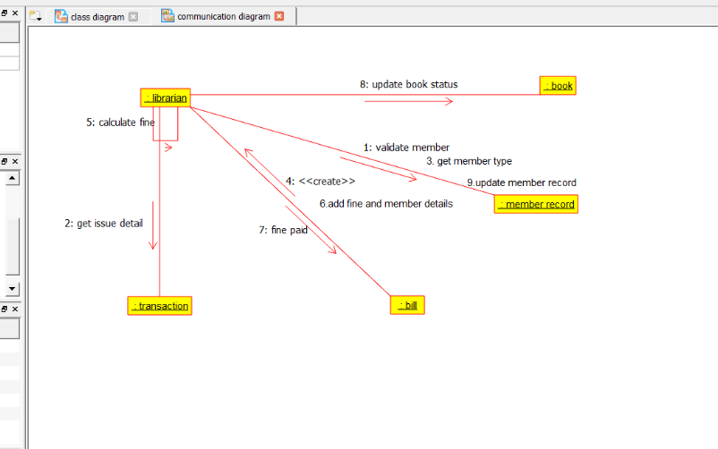

STATE CHART DIAGRAM

